Drought | قَحْطٌ
Dream | رُؤْيَا
Generous | جَوَادًا
Wolf | ذِئْبٌ
Wisdom | حِكْمَةٌ
Prison | سجن
Different | مُتَفَرِّقُوْنَ
Rain | مَطَرٌ
Evil | شَّرّ
Innocent | بَرِئٌ
Advice | مَوْعِظَةٌ
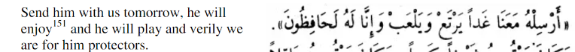
What is the Arabic to these Verb keywords, give the past and present tense verbs
To crucify | صَلَبَ يَصْلِبُ
To forget | نَسِيَ يَنسَى
To tear | شَقَّ يَشُقُّ
To buy | اِشْتَرَي, يَشْتَرِي
To honour | اَكْرَمَ, يُكْرِمُ
To permit | أَذِنَ يَأْذَنُ
To betray | خَانَ يَخُوْن
To squeeze | عَصَرَ يَعْصِرُ
To speak out | جَهَرَ يَجْهَرُ
To be humble | خَضَعَ يَخْضَعُ
To name | يُسَمِّي سَمَّى

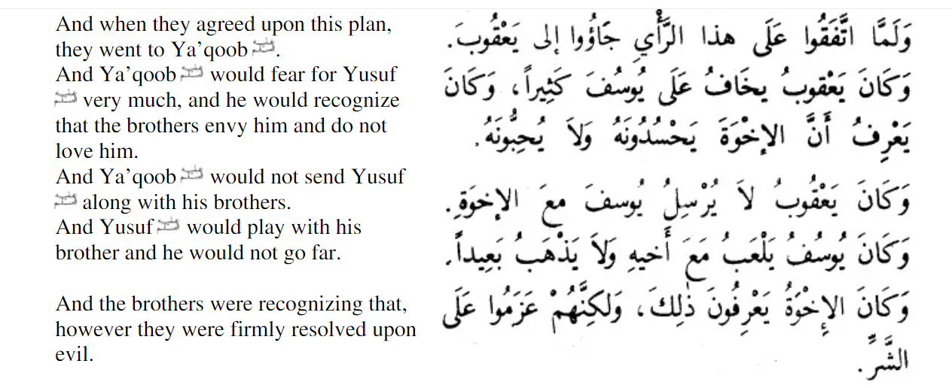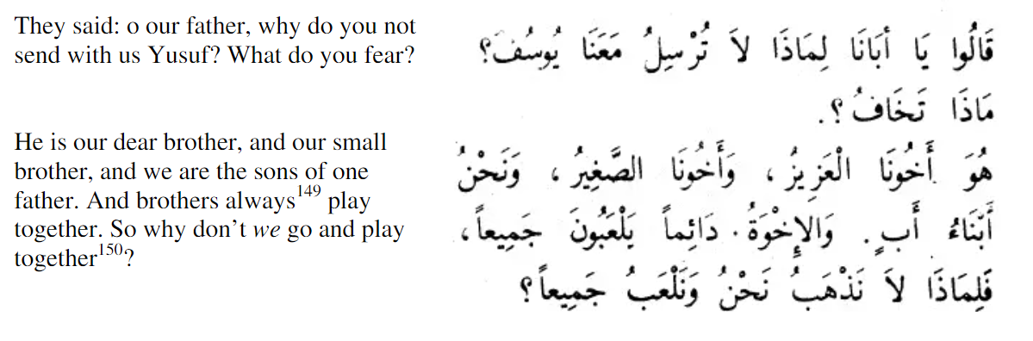

What was the dream of the king and its interpretation? The king saw dream in which he say 7 skinny cows eating 7 fat cows this meant that there will be 7 years of famine followed by 7 years of harvest
What was the two dreams of the two men in the prison? Man 1 – He saw a dream where the birds were eating the bread he was holding on his head
Man 2- He saw a dream where he was squeezing wine
Why did Yusuf (as) brothers leave him in the well?
They were jealous of the attention he would get from their father
Analyse the following sentence
وَكَانَ يعقوبُ يخَافُ علَى يُوسُفَ كَثِيرا Analyse the following sentence

Translate the text:
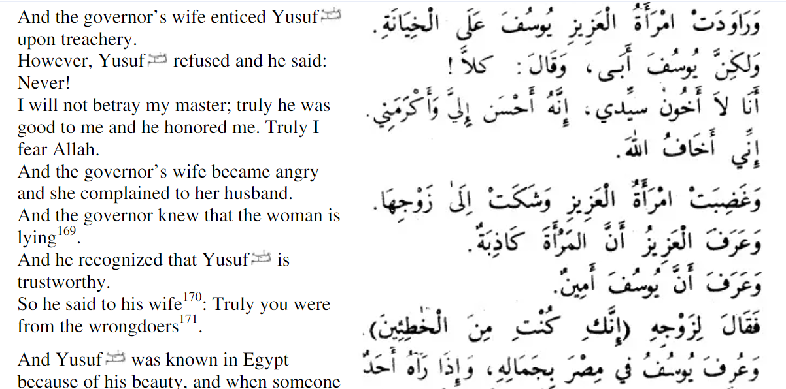
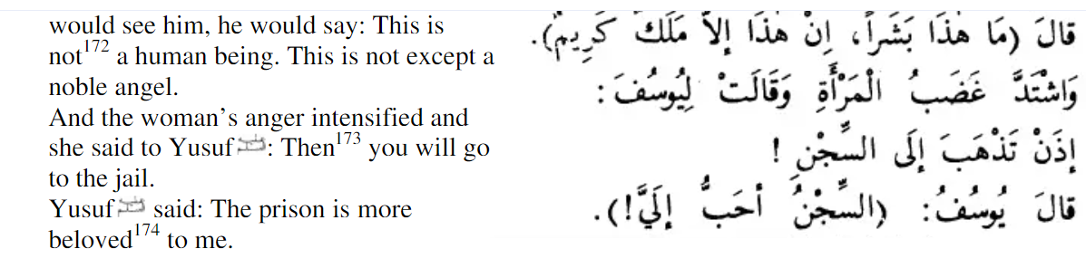
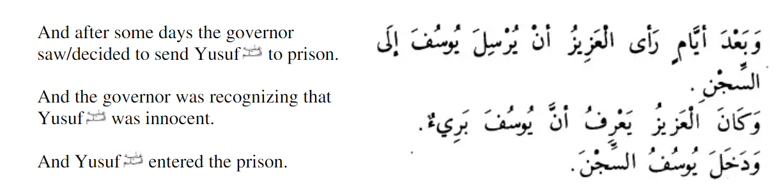
What is the Arabic to these Nouns/particles keywords:
Qasas revision – Story of Yusuf (as) 1– 14

Analyse the following sentence and explain the rule why the number seven is masculine
ورأى الملك سبع سنبلات

Analyse these words with their plurality singular nouns and meanings

يابسات أنبياء أَحَدُهما أبيا

